Group News
Recent Award
ICME Conference 2020
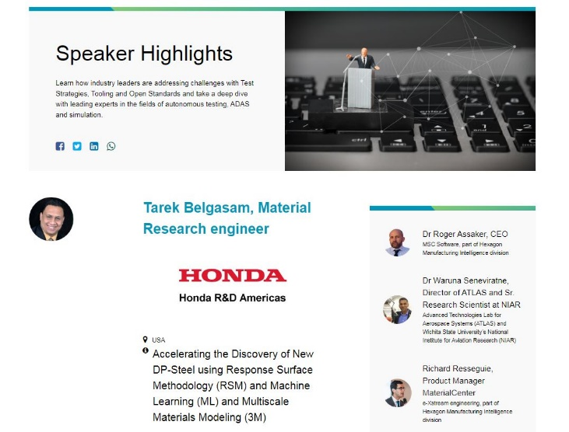
Dr. Tarek Belgasim has been invited as a ICME Conference introducer. The ICME Conference 2020, a HxGN LIVE event is a 3-days intensive online conference on October 6-8, 2020 for executives, R&D, manufacturing professionals, engineers, and designers to learn, explore and share about Integrated Computational Materials Engineering (ICME) to enable companies to blur the boundaries between manufacturing, materials and part performance for the optimal design of innovative quality products. As a bonus, we offer you free workshops
https://icmeconference.com/the-event/

CWB 2018 conference golden award for outstanding presentation.
Dr. Abdelbaset R H Midawi has received Gold Medal Award in CanWeld. Each year in the post CanWeld Conference survey, the audience has an opportunity to select the best conference paper presentation Gold award. The 2019 CanWeld Conference Gold Award is presented this year to CAMJ Post-doctoral fellow Dr. Abdelbaset Midawi for his paper: Mechanical Property Characterization for X80 Pipeline Steel Welds using indentation.
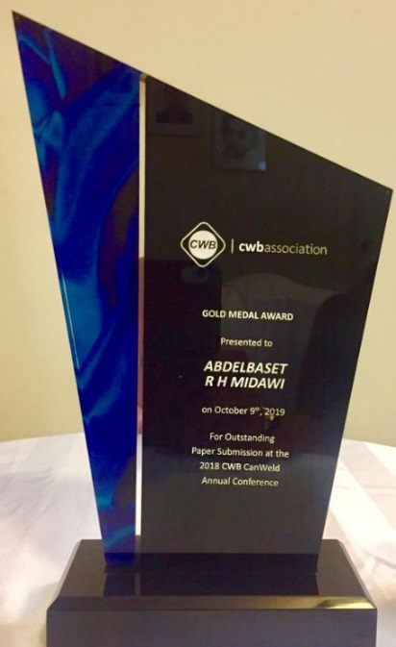
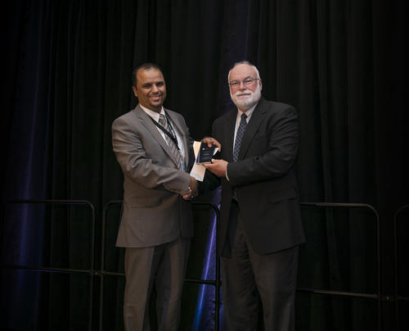
https://uwaterloo.ca/centre-advanced-materials-joining/news/cwb-canweld-annal-conference-gold-medal-award-camj-member
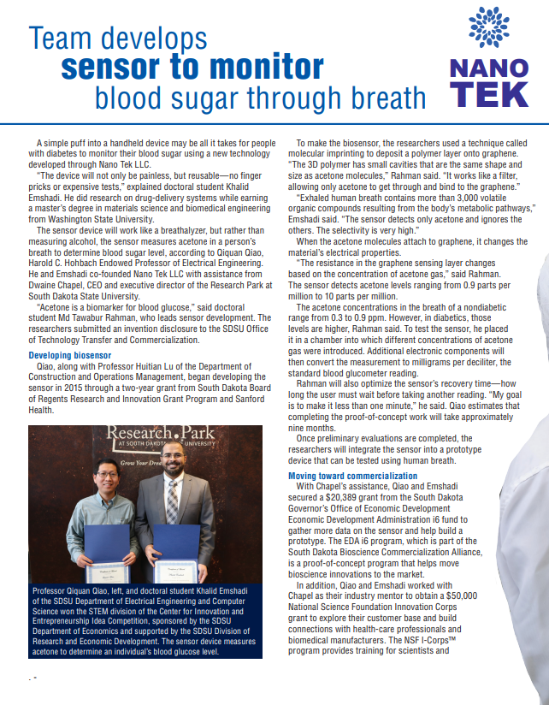

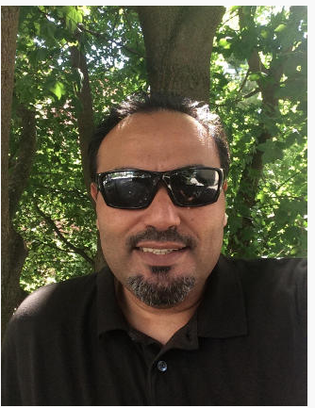

Osama Fakron
(M.S., '17 Mathematics)
Osama Fakron is in his first year as a mathematics instructor for engineering students at Virginia Polytechnic Institute and State University, a public, land-grant, research university in Blacksburg, Virginia. Osama earned a Ph.D. in engineering from WSU in 2014 and a M.S. in mathematics in 2017. "I appreciate the high quality of the education I received at WSU and the opportunities it has provided me. Virginia Tech is a great place for learning, for both students and instructors. I live in the town of Blacksburg, which is a little bigger than Pullman. The life and people in Blacksburg are somewhat different compared to Pullman, but it is a very nice and safe place to live and raise a family." Recently, Dr. Fackron has accepted a job offer from Mavajo Technical University as an assistant professor.

Recent and significant articles
A. R. H. Midawi, N. Huda, C. H. M. Simha, A. P. Gerlich “Characterization of Anisotropy of Strength in API-X80 Line Pipe Welds through Instrumented Indentation” Accepted 13th of October, 2020 at Metallography, Microstructure, and Analysis an ASM International, (In press)
LHA Shah, A R H Midawi, S Walbridge, A Gerlich “Influence of tool eccentricity on the material flow and microstructural properties of AA6061 aluminum alloy friction stir welds”, Journal of Alloys and Compounds 826, 154219, https://doi.org/10.1016/j.jallcom.2020.154219,
A. R. H. Midawi, C. H. M. Simha, A. P. Gerlich, “Assessment of yield strength mismatch in X80 pipeline steel welds using instrumented indentation”, International Journal of Pressure Vessels and Piping 2018. https://doi.org/10.1016/j.ijpvp.2018.09.014

Khalid Emshadi Nabin Ghimire Ashim Gurung Behzad Bahrami Rajesh Pathak Raja Sekhar Bobba Buddhi Sagar Lamsal Sheikh Ifatur Rahman Ashraful Haider Chowdhury Ke Chen Md Ashiqur Rahman Laskar Wenqin Luo Hytham Elbohy Quinn Qiao “Tailoring the Grain Boundaries of Wide‐Bandgap Perovskite Solar Cells by Molecular Engineering”, https://doi.org/10.1002/solr.202000384

Sheikh Ifatur Rahman, Buddhi Sagar Lamsal, Ashim Gurung, Ashraful Haider Chowdhury, Khan Mamun Reza, Nabin Ghimire, Behzad Bahrami, Wenqin Luo, Raja Sekhar Bobba, Jyotshna Pokharel, Abiral Baniya, Ashiqur Rahman Laskar, Khalid Emshadi, Md Tawabur Rahman, and Quinn Qia,“Grain Boundary Defect Passivation of Triple Cation Mixed Halide Perovskite with Hydrazine-Based Aromatic Iodide for Efficiency Improvement”, ACS Applied Materials & Interfaces 2020 12 (37), 41312-41322, https://DOI:10.1021/acsami.0c10448

Abdallah A Chehade, Tarek M Belgasam, Georges Ayoub, Hussein M Zbib “Accelerating the Discovery of New DP Steel Using Machine Learning-Based Multiscale Materials Simulations”, Metallurgical and Materials Transactions A, https://link.springer.com/article/10.1007/s11661-020-05764-7
Tarek M Belgasam, Hussein M Zbib “Key factors influencing the energy absorption of dual-phase steels: multiscale material model approach and microstructural optimization”, Metallurgical and Materials Transactions A, https://link.springer.com/article/10.1007/s11661-018-4563-x
Khaled Adam and Tarek Belgasim “A Parametric Study of Grains size and their Volume Fraction Effect on Heterogeneous Materials Mechanical properties” MS&T2021 Supplemental Proceedings (In press)
Khaled Adam, Dana Zöllner and David P. Field “3D Mesoscopic Simulation of Static Recrystallization and Grain Growth in Hot Rolled Single Phase Alloys”, 2018 http://iopscience.iop.org/article/10.1088/1361-651X/aaa146/pdf
Adam, K.F., Long, Z. & Field, D.P. Metall and Mat Trans A (2017) 48: 2062. https://doi.org/10.1007/s11661-017-3967-3
Anazi, M. H., & Zbib, H. M. (2018). “A Continuum Deformation Model for Steel Coated with Nanolaminate Metallic Systems”. Metallurgical and Materials Transactions A, 1-17. https://doi.org/10.1007/s11661-018-4939-y

Damadam M, Anazi M, Ayoub G, Zbib H. (2019). “Atomistically-informed and dislocation-based viscoplasticity model for multilayer composite thin films”. ASME. J. Eng. Mater. Technol. 2019; 141(2):021010. doi:10.1115/1.4042034. https://doi.org/10.1115/1.4042034

Anazi, M. H., & Zbib, H. M. (2018). “A Continuum Model of Deformation and Damage for API X70 Steel Based on the Theory of Strain Gradient” 15th International LS-DYNA Conference, 1-12. https://www.dynalook.com/conferences/15th-international-ls-dyna-conference/constitutive-modeling/a-continuum-model-of-deformation-and-damage-for-api-x70-steel-based-on-the-theory-of-strain-gradient

Fakron, O. M. and Field, D. P. “3D Image Reconstruction of Fiber Systems Using Electron Tomography. Ultramicroscopy. 149, 21-25. http://dx.doi.org/10.1016/j.ultramic.2014.10.012 (2015).
Fakron, O. M. and Field, D. “SEM-Based Electron Tomography of Turfs Comprised of Lineal Structures.”Microscopy and Microanalysis. 17, 990-991. http://dx.doi.org/10.1017/S1431927611005824 (2011).
KY Benyounis, OMA Fakron, JH Abboud, AG Olabi, MJS Hashmi “Surface melting of nodular cast iron by Nd-YAG laser and TIG Journal of Materials Processing Technology” 170 (1-2), 127-132

